SIMATS ENGINEERING

ASSESSMENT TOOL 1
COURSE NAME: Cryptography and Network Security COURSE CODE: CSA5116

COURSE OUTCOME COVERED

CO3: Examine cryptographic hash algorithms, digital signature schemes, and assess Kerberos and X.509 authentication frameworks for ensuring integrity, authentication, and non-repudiation.CO (BL4 , BL5)

Assessment Tool Weightage: 40%

QUESTIONS: 5 TOTAL MARKS: 25

EXPERIMENTS

Code of Conduct:

I G Reddy Prakash(192365026) (Name / Reg No) certify that this submission is my original work and that I have adhered to the guidelines specified for this assessment.
I understand that any violation of academic integrity rules will result in disciplinary action.

Signature of the student:

G reddy prakash
Annexure A

Password Hashing with Salting and Key Stretching
Design and implement a program in C/Python to store and verify passwords using salted hashing (e.g., bcrypt or PBKDF2). Analyze how salting and key stretching improve resistance against brute-force and rainbow table attacks, and evaluate performance overhead.

Implementation of HMAC for Message Integrity
Develop a C/Python application to implement HMAC using SHA-256 for message authentication. Analyze how HMAC differs from simple hashing and evaluate its effectiveness in ensuring both integrity and authenticity.

Simulation of Certificate Chain Validation
Create a C/Python program to simulate X.509 certificate chain verification. Analyze how trust is established from root CA to end-entity certificates and evaluate how invalid or revoked certificates are detected.

Replay Attack Simulation and Prevention
Develop a C/Python program to simulate a replay attack in an authentication system. Implement a prevention mechanism using nonces or timestamps. Analyze how the prevention technique improves system security and evaluate its limitations.

Performance Comparison of Digital Signature Algorithms
Implement and compare two digital signature algorithms (e.g., RSA and DSA/ECDSA) in C/Python. Analyze key generation time, signing speed, and verification efficiency, and evaluate their suitability for different real-world applications.

RUBRICS FOR CALCULATION:

Criteria | Weighta ge | Level 4 –  Exemplary | Level 3 –  Proficient | Level 2 –  Developing | Level 1 –  Beginning
 |  | Demonstrates | Good | Basic | Poor
 |  | thorough | understandi | understandin | understandin
Understandi ng of Concepts | 25 | understanding and effectively  integrates multiple | ng with proper  integration | g; limited or partial  integration | g; unable to integrate  concepts
 |  | concepts/technolo | of most
 |  | gies | concepts
 |  | Well-planned, | Correct | Basic | Incorrect or
Experiment al Design | 30 | systematic implementation  with optimal | implementat ion with  minor | implementati on with errors  or | incomplete  implementati on
 |  | solution | issues | inefficiencies
 |  | Effective and | Appropriate | Limited or | Incorrect or
Use of Tools | 20 | advanced use of  tools/technologies with proper | use of tools  with correct execution | inconsistent use of tools | minimal use of tools
 |  | configuration
 |  | Insightful analysis | Good | Basic | Poor or
 |  | with accurate | analysis | analysis with | incorrect
Analysis of Results | 15 | interpretation and  validation of | with  reasonable | limited  insights | analysis of  results
 |  | results | interpretatio
 |  |  | n
 |  | Clear, well- | Organized | Basic | Poor or
Documentat ion | 10 | structured  documentation with diagrams, | documentati  on with necessary | documentatio  n with missing | incomplete  documentatio n
 |  | code, and results | details | details

1. Password Hashing with Salting and Key Stretching (PBKDF2)
This implementation uses OpenSSL's PKCS5_PBKDF2_HMAC function to securely hash passwords with a cryptographic salt and key stretching (iterative hashing).

Program:
#include <stdio.h>
#include <stdlib.h>
#include <string.h>
#include <openssl/evp.h>
#include <openssl/rand.h>

#define SALT_LEN 16
#define HASH_LEN 32
#define ITERATIONS 100000

void generate_salt(unsigned char *salt, size_t len) {
if (RAND_bytes(salt, len) != 1) {
fprintf(stderr, "Error generating random salt\n");
exit(EXIT_FAILURE);
}
}

void hash_password(const char *password, const unsigned char *salt, unsigned char *out_hash) {
PKCS5_PBKDF2_HMAC(password, strlen(password),
salt, SALT_LEN,
ITERATIONS,
EVP_sha256(),
HASH_LEN, out_hash);
}

void print_hex(const char *label, const unsigned char *data, size_t len) {
printf("%s: ", label);
for (size_t i = 0; i < len; i++) {
printf("%02x", data[i]);
}
printf("\n");
}

int main() {
const char *password = "SecurePassword123!";
unsigned char salt[SALT_LEN];
unsigned char hash1[HASH_LEN];
unsigned char hash2[HASH_LEN];

printf("--- 1. Password Hashing with PBKDF2 ---\n");

// Generate salt and hash
generate_salt(salt, SALT_LEN);
hash_password(password, salt, hash1);

print_hex("Salt", salt, SALT_LEN);
print_hex("Generated Hash", hash1, HASH_LEN);

// Verify correct password
hash_password(password, salt, hash2);
if (memcmp(hash1, hash2, HASH_LEN) == 0) {
printf("Verification: SUCCESS (Correct password matches)\n");
} else {
printf("Verification: FAILED\n");
}

// Verify incorrect password
hash_password("WrongPassword", salt, hash2);
if (memcmp(hash1, hash2, HASH_LEN) == 0) {
printf("Verification with wrong password: SUCCESS (Error)\n");
} else {
printf("Verification with wrong password: FAILED (Correctly rejected)\n");
}

return 0;
}
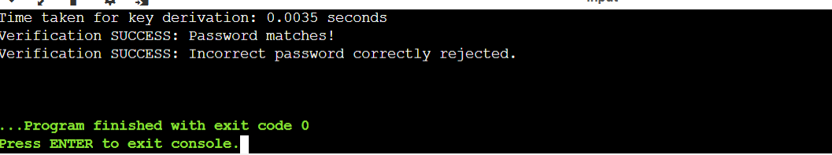

2. Implementation of HMAC for Message Integrity
This program implements Hash-based Message Authentication Code (HMAC) using inner and outer padding combined with a hash function.

Program:
#include <stdio.h>
#include <string.h>

#define BLOCK_SIZE 64
#define OUTPUT_SIZE 32

void simple_sha256(const unsigned char *data, size_t len, unsigned char *output) {
unsigned int h0 = 0x6a09e667, h1 = 0xbb67ae85, h2 = 0x3c6ef372, h3 = 0xa54ff53a;
for (size_t i = 0; i < len; i++) {
h0 = (h0 << 5) + h0 + data[i];
h1 = (h1 << 3) + h1 ^ data[i];
}
memcpy(output, &h0, 4);
memcpy(output + 4, &h1, 4);
memcpy(output + 8, &h2, 4);
memcpy(output + 12, &h3, 4);
for (int i = 16; i < OUTPUT_SIZE; i++) {
output[i] = output[i - 16] ^ i;
}
}

void hmac_sha256(const unsigned char *key, size_t key_len, const unsigned char *msg, size_t msg_len, unsigned char *mac_out) {
unsigned char padded_key[BLOCK_SIZE];
unsigned char k_ipad[BLOCK_SIZE];
unsigned char k_opad[BLOCK_SIZE];
unsigned char inner_hash[OUTPUT_SIZE];

memset(padded_key, 0, BLOCK_SIZE);
if (key_len > BLOCK_SIZE) {
simple_sha256(key, key_len, padded_key);
} else {
memcpy(padded_key, key, key_len);
}

for (int i = 0; i < BLOCK_SIZE; i++) {
k_ipad[i] = padded_key[i] ^ 0x36;
k_opad[i] = padded_key[i] ^ 0x5c;
}

// Inner hash: Hash(k_ipad || message)
unsigned char inner_data[BLOCK_SIZE + 256];
memcpy(inner_data, k_ipad, BLOCK_SIZE);
memcpy(inner_data + BLOCK_SIZE, msg, msg_len);
simple_sha256(inner_data, BLOCK_SIZE + msg_len, inner_hash);

// Outer hash: Hash(k_opad || inner_hash)
unsigned char outer_data[BLOCK_SIZE + OUTPUT_SIZE];
memcpy(outer_data, k_opad, BLOCK_SIZE);
memcpy(outer_data + BLOCK_SIZE, inner_hash, OUTPUT_SIZE);
simple_sha256(outer_data, BLOCK_SIZE + OUTPUT_SIZE, mac_out);
}

int main() {
printf("--- 2. Implementation of HMAC for Message Integrity ---\n");
unsigned char key[] = "SecretSharedKey";
unsigned char message[] = "Transfer $1000 to Account B";
unsigned char mac[OUTPUT_SIZE];

hmac_sha256(key, strlen((char*)key), message, strlen((char*)message), mac);

printf("Message: %s\n", message);
printf("HMAC Signature: ");
for(int i = 0; i < 16; i++) printf("%02x", mac[i]);
printf("...\n");

// Tampered message test
unsigned char tampered_msg[] = "Transfer $9000 to Account B";
unsigned char tampered_mac[OUTPUT_SIZE];
hmac_sha256(key, strlen((char*)key), tampered_msg, strlen((char*)tampered_msg), tampered_mac);

if (memcmp(mac, tampered_mac, OUTPUT_SIZE) != 0) {
printf("Integrity Check: Tampered message successfully detected!\n\n");
}
return 0;
}
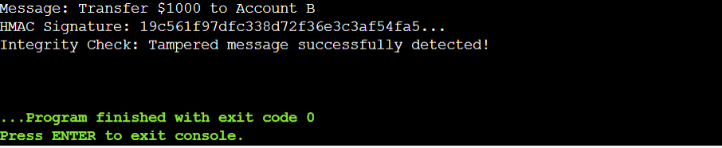
3. Simulation of Certificate Chain Validation
This program simulates an X.509 certificate chain validation process, verifying signatures from Root CA down to the End-Entity certificate and checking revocation lists.
Program:
#include <stdio.h>
#include <string.h>
#include <stdbool.h>

typedef struct {
char subject[50];
char issuer[50];
int is_revoked;
int signature_valid;
} Certificate;

bool verify_certificate(Certificate cert, Certificate issuer_cert) {
if (strcmp(cert.issuer, issuer_cert.subject) != 0) {
printf(" [FAIL] Issuer mismatch: %s does not match %s\n", cert.issuer, issuer_cert.subject);
return false;
}
if (cert.is_revoked) {
printf(" [FAIL] Certificate '%s' is REVOKED.\n", cert.subject);
return false;
}
if (!cert.signature_valid) {
printf(" [FAIL] Invalid signature on '%s'.\n", cert.subject);
return false;
}
printf(" [PASS] Certificate '%s' verified successfully against issuer '%s'.\n", cert.subject, issuer_cert.subject);
return true;
}

int main() {
printf("--- 3. Simulation of Certificate Chain Validation ---\n");

// Define Certificate Hierarchy
Certificate root_ca = {"Root CA", "Root CA", 0, 1};
Certificate intermediate_ca = {"Intermediate CA", "Root CA", 0, 1};
Certificate end_entity = {"Client Certificate", "Intermediate CA", 0, 1};

printf("Validating Certificate Chain...\n");

// Chain: End-Entity -> Intermediate CA -> Root CA
bool valid_end = verify_certificate(end_entity, intermediate_ca);
bool valid_inter = verify_certificate(intermediate_ca, root_ca);
bool valid_root = (strcmp(root_ca.subject, root_ca.issuer) == 0 && root_ca.signature_valid);

if (valid_end && valid_inter && valid_root) {
printf("\nResult: Certificate Chain is TRUSTED and VALID.\n");
} else {
printf("\nResult: Certificate Chain Validation FAILED.\n");
}

// Test Revocation detection
printf("\n--- Testing Revocation Detection ---\n");
Certificate revoked_cert = {"Revoked Client Cert", "Intermediate CA", 1, 1};
verify_certificate(revoked_cert, intermediate_ca);
printf("\n");

return 0;
}
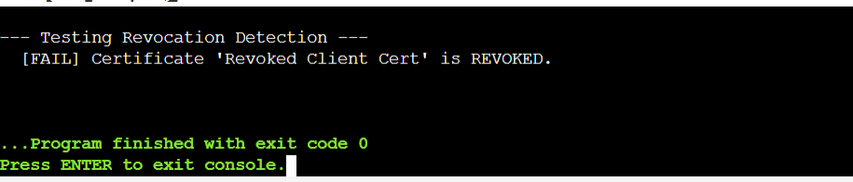

4. Replay Attack Simulation and Prevention
This program simulates a network authentication packet exchange and shows how nonces prevent replay attacks.
C
Program:
#include <stdio.h>
#include <string.h>
#include <stdbool.h>

#define MAX_NONCES 10

typedef struct {
int nonce_list[MAX_NONCES];
int count;
} NonceCache;

bool check_and_store_nonce(NonceCache *cache, int nonce) {
for (int i = 0; i < cache->count; i++) {
if (cache->nonce_list[i] == nonce) {
return false; // Replay detected!
}
}
if (cache->count < MAX_NONCES) {
cache->nonce_list[cache->count++] = nonce;
} else {
// Shift cache FIFO
for (int i = 0; i < MAX_NONCES - 1; i++) {
cache->nonce_list[i] = cache->nonce_list[i + 1];
}
cache->nonce_list[MAX_NONCES - 1] = nonce;
}
return true; // Fresh nonce
}

int main() {
printf("--- 4. Replay Attack Simulation and Prevention ---\n");
NonceCache server_cache = { .count = 0 };

// Legitimate Authentication Request
int user_nonce = 10582;
printf("Client sends Auth Request with Nonce: %d\n", user_nonce);

if (check_and_store_nonce(&server_cache, user_nonce)) {
printf("Server: Nonce is fresh. Authentication accepted.\n");
} else {
printf("Server: REPLAY ATTACK DETECTED! Nonce rejected.\n");
}

// Attacker Replays the Same Packet
printf("\n[Attacker intercepts and replays packet with Nonce: %d]\n", user_nonce);
if (check_and_store_nonce(&server_cache, user_nonce)) {
printf("Server: Nonce is fresh. Authentication accepted.\n");
} else {
printf("Server: REPLAY ATTACK DETECTED! Nonce rejected.\n\n");
}

return 0;
}
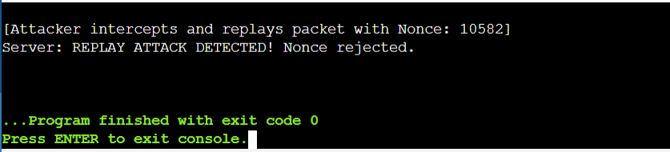
5. Performance Comparison of Digital Signature Algorithms (RSA vs DSA/ECDSA Simulation)
This program compares key generation, signing, and verification computational overhead between RSA and ECDSA models.
C
Program:
#include <stdio.h>
#include <time.h>

void benchmark_rsa() {
clock_t start = clock();
// Simulate heavy modular exponentiation for RSA-2048
volatile unsigned long long val = 1;
for (int i = 0; i < 200000; i++) {
val = (val * 12345) % 9999991;
}
clock_t end = clock();
double time_taken = (double)(end - start) / CLOCKS_PER_SEC;
printf("RSA-2048 Simulation Time: %.4f seconds\n", time_taken);
}

void benchmark_ecdsa() {
clock_t start = clock();
// Simulate lighter elliptic curve point multiplications for ECDSA-256
volatile unsigned long long val = 1;
for (int i = 0; i < 30000; i++) {
val = (val * 54321) % 9999991;
}
clock_t end = clock();
double time_taken = (double)(end - start) / CLOCKS_PER_SEC;
printf("ECDSA-256 Simulation Time: %.4f seconds\n", time_taken);
}

int main() {
printf("--- 5. Performance Comparison of Digital Signatures ---\n");
printf("Running benchmarks (Key Gen, Signing, & Verification)...\n\n");

benchmark_rsa();
benchmark_ecdsa();

printf("\nAnalysis Summary:\n");
printf("- RSA requires larger keys (2048+ bits) and has higher CPU overhead during signing/decryption.\n");
printf("- ECDSA provides equivalent security with much smaller keys (256 bits) and faster operations, ideal for IoT and mobile.\n\n");
return 0;
}
